HOW WORK JAVA WITH FRONTEND AND BACKEND

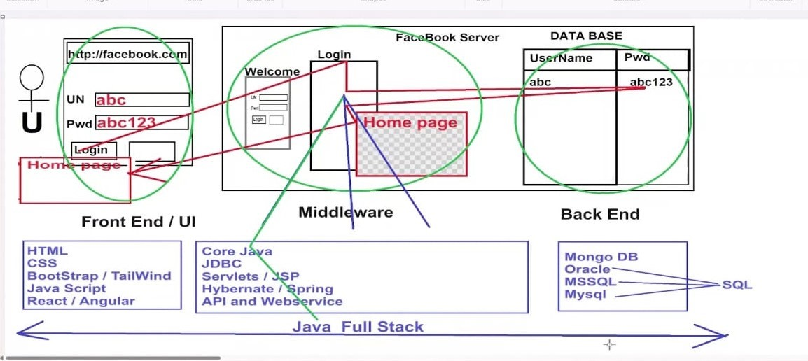

What is java ?
- Java is high level object oriented programming language
- Develop computer based applications
- JAVA – JUST ANOTHER VIRTUAL ACCELERATOR.
Why do we use java?
JAVA is popular programming language used in wide range of application because of its platforms independence, robustness, simplicity, and scalability.
Features of java:
Java is very simple language and syntax of java is easy.
Java is platform independent
Java is estensible means java program can integrate with any programming lang like (c, c++, phython)
Java is oop language
Java is robust means java can under huge communication, Java has automatic garbage collector
Programming Language :-
Programming language is a medium or mode of communication which is used to communicate with systems / machines.
Types of programming language:
- Low Level Language – understood by system or machine, it contains binary code(0s,1s).
- High Level Language – understood only by human beings.
- Mid Level Language (Intermediate, Assemble Language). – Partially understood by human being as well as system.
Platform
Platform is a place where we write some set of Instrictions. Eg: OS
Types of platform:-
Platform Independent – app develop on 1os to any os(operating system)

RUN
WINDOW
APP
WINDOW OS
RUN
LINUX

RUN
MAC

Platform Dependent – app develop 1 os can run in same os.
RUN
WINDOW
APP
WINDOW OS
Not run
LINUX

Not run
MAC

History of JAVA
- Another name of java ? wora
- Who introduced java? James Gosling
- Which company introduced java? SMS(sun micro system)
- What is the previous name of java? OAK- strong
- In which year, java has been introduced ? In the year 1995
- Who is current owner of java? ORACLE.

STRUCTURE OF JAVA PROGRAM
Create a file , Compilation, Execute.
1, Create a file -
1, class
2,intetface

FilenName.extension
CLASS- it is pre defined word , keyword also
Eg: Syntax class className{
- Declaration statement
- Initilization.
}
2, Compilation
- If we run java program we need software called compiler,take .javafile as input and read byte code line by line of there is any mistake we will throw the file along with error message.
- If there is no mistake, then complier will generate one more file called .classfile
- Syntax: javac filename.java
Create a file Compilation Execute(JRE )
Complier
Class Demo{
}
}

Demo.java Demo.java Demo.class Demo.class
Editor (software) Notepad , notepad++, visual studio, Eclipse

3)Execute
- If we want to execute java program main method is mandatory.
- JRE will always starts the execusion from main method.(JRE is software that java program require to run correctly)
SYNTAX :
Public static void main (String [ ] args)
{
// set of instruction
}
Printing Statement: To print the data in output console
1)System.out.print(“hi”); - same line
2)System.out.println(“hlo”); - next line
Example program:
1) Psvm(){ output: Good moring hi how are you
S.O.P(“Good morning”);
S.O.P(“hi how are you”);
}
2) psvm(){ output: Good morning
S.O.Pln(“Good morning”); hi how are you
S.O.Pln(“hi how are you”);
}
3) psvm(){
S.O.P(“Good morning”);
S.O.Pln(“Good morning”);

S.O.P(“hello”);
S.O.Pln(“hi how are you”);
}

Tokens:-
* Tokens are nothing but smallest component of any programming Language
* Programming Languages should also have Alphabets & Words that is called as tokens.
Tokens are classified into 3 types
* Keywords
* Identifiers
* Literals
Keywords:
* Keywords are nothing but pre defined words which are aware from by the compiler. In Java we have 50+ keywords. It should be specified in lower case only.
Eg: class Demo { Class Demo { CLASS hi {

} //CTS } //CTE } //CTE
Identifiers:
* Identifiers is a name given to java compiler
Identifiers
Java
class
Class name
component
* with respect to identifiers we have to follow two things.
1) Rules 2) Conventions.
(1)Rules :–
- Identifiers cannot start with numbers
class Demo{ class 1Demo{ class Demo1{
} //CTS } //CTE } //CTS
- Only $ and _ are used
class Sample1${ class hi hello{ class Demo#1{
} //CTS } //CTE } //CTE
- Keywords cannot be used as identifiers
class Public{ class class{ class Class{
} //CTs } //CTE } //CTS

(2) CONVENTION:-
Convention are nothing but industry standard. programmer we have to follow.
With respect to naming convention we have to upper camel case means every 1st letter should be in capital Letter.
Java Program
class → upper camal cause
Note: Compiler will not check for naming conversion.
Literals:-
- Any data passed by the programmer in a program is known as Literals.
EG: Class Demo{
public static void main(String[] args){
System.out.print ("note”);
}
LITERALS ARE CLASSIFIED INTO FOUR TYPES:-
1) Number Literal -Decimal , integer.
2) Character Literal - represent single code ex :‘a’ , a-variable
3) String Literal - represent double code
4)Boolean Literal – true represent logical high, false low . true and false both are keyword.
Examples: class Literals{
Psvm(){
//Number Literals System.out.println(10);//10
System.out.println(10.5);//10.5
//character literal System.out.print (‘a’);//0
//String literal System.out.print ("Hello");
//Boolean Literas System.out.print (true);
System.out.print (false);
}}
VARIABLES:-
- Variable is a block of memory or container which is used to store the data, Reintialization is possible.
- Variable declaration - Syntax: Data types variable name /identifier;
Example: int a:
Data type: Datatype specifies which type of container has to be created
- Variable Initialization – Syntax: identifier = value;
Example: a=10;
- Variable declaration and initializations – Syntax : Datatype VN/identifier = value;
Example: int c =18; int a =10;
Program:
- Class Variable{
Psvm(){
//store variable declaration
Int a;
//store var int
a=100;
System.out.print (a);//100
//dec and inti
Int score=40;
System.out.print (score);//40
}}
- Class advantages{
Psvm(){
Int age =20;
// reintilization
Int age =21;
Int age=23;
System.out.print (age);//20,23
}}
- Class Variable{
Psvm(){
Int a;
a=20,30;System.out.print (a)}}//cte
Types of variables
- Based on datatypes- Primitive & Non-Primitive
- Based on scope- Local variable,static &Nonstatic
Primitive Variable
A Variable which is used to create to store primitive data known as primitive variable
Primitive data
Any data which can be stored in single block of memory without any complexity
Ex: 10,10.5,’a’…..
o primitive data we have 8 data types
Type of variable | Datatypes | Bytes | Bits | Default values
Integer | Byte  Short  Int  long | 1  2  4  8 | 8  16  32  64 | 0  0  0  0
character | char | 2 | 16 | /u000
Decimal | Float  double | 4  8 | 32  64 | 0.0  0.0
Boolean | boolean | - | 1 | false

Program:-
- Class Datatype{
Psvm(){
byte a = 125; System.out.println (a);
short b = 175; System.out.println (b);
int c = 50555; System.out.println(c);
long l= 9848586838l ; System out. println (l);
// Decimal Number
float f = 12.6f System.out.println (f); //
double d= I7.70; System.out.println(d); // 17.70
// character
char y = `k'; Systern out-printin (y); //k
// Boolean
boolean z= true; Systern out-printin (z); } }
Non Primitive Variable
A Variable which is used to create to store address of non primitive data .
Non Primitive data
Any data which cannot be stored in single block of memory instead which requires multiple block of memory. Non Primitive Var
0*2
1)”Hello” a Non primitive data
H | E | L | L | O
2)10, 20, 30,….
Local Variables:-
Any variables which are declared in a dedicated block other than class block .
characteristics: 1. Local variables doesn't have default values
class Local{
public static void main(String[] args){
int a ;
System.out.println(a); CTE } }
2) Local variables cannot have same name
Ex: class Local{
public static void main(String[]angs){
int a = 80; System.out.println(a);
double a = 15.5; System.out.println(a); //cte }
}
3) Local variable can be accessed block where it has been declared.
Ex: Class Local{
public static void main(String[]angs){
{//nested block
int a = 80; System.out.println(a); //cte
} } }
Program:
Class Local{
Psvm(){
{ int a = 80;
{
S.O.P(a);// }
System.out.pln(a);//
}
S.O.PL(a);// } } }
Type Casting - one type of data into another type is known as type- casting.
Ex: double a=10; System.out.pln(a);//10.0
who can do this type-casting : 1. Compiler 2. Programmer
Types of Type-casting:
Type Casting Upcasting

Primitive Casting Derived/Non PC
Downcasting
Widening Narrowing
Primitive Casting: one type of primitive data into another primitive type
Widening- Converting lower datatype to higher datatype ex: int a =10; double b=a;//10.0
Narrowing - Converting higher datatype to lower datatype ex: double b=1.5; (8)
int a=b;//cte
Note:
- Widening implicity by the complier
- Narrowing explicitly by the programmer by using typecasting operator
Syntax: (datatype) variable Name;
Program: 1) class Demo{ 2)class Demo1{
Psvm(){ Double a=10; //Wid S.O.Pln(a);//
Int a=10;//4 int b=(int)a; S.O.Pln(b);//10
Double b=10; //8 char c= 65; S.O.Pln(c)://
System.out.pln(a);// int res1 = ‘a’+’d’; //97+100
System.out.pln(b);// }} S.O.Pln(res1)://197 }}
Operators:- Operators are nothing but predefined symbols which are used to perform some specifictask.
Ex:+, -,*, /-------etc.

Ex: 10+20
Operators
Operands
Expression
10 + 20

Operands: operands are nothing but values.
Expression: Combination of operands + operators
Ex: class Addition{
Psvm(){
S.O.Pln(10+20); //30
Int a,b ;

a = 20;
b = 40; S.O.Pln(a+b);// 60 } }
Characteristics :-
1)Each and every operator will return 2 things *Types of data * Results
Class kavi {
Psvm(){
Int a = ‘a’;
Int b =20 ;
Byte res = a+b ; S.O.Pln(a+b);//CTE } }
2)_Presidence: means priority. Whenever we have more than one operator presidence will comes into picture. Ex: Psvm(){
S.O.Pln(10+20*3);//70 board mass
3)Associativity : means direction or order of execution
When ever we have complex operator with same priority then associativity will comes into picture (Bydefault left to right). Ex: 10 + 20+ 30 + 40 ;
TYPES OF OPERATORS:
OPERATORS
Based on operators Based on task

Based on operators: Binary, Ternary , Unary.
Based on task : Arithmetic, Relational, Logical, Assignment , CompoundAss , Left shift ,Right.
Arithmetic Operator: we have 5 types (+, -, *, /, %).
+ operator: it has 2 behaviours. 1) Addition 2)Concat
Note: whenever we try to perform add operation with string type data will act like concat…
EX: 10 + “Hello” - o/p: 10Hello
10 + 20+”Hi” -o/p: 30Hi
Hello + 80 + 50 - O/P: Hello8050
50 + true - o/p: CTE
ASCII VALUES: (Unique integer number)
A(65) …………… Z(90) a(97) ……..………….. z(122) 0(48) …………… 9(57)
Ex: psvm(){
Int a = 50;
Int b = 60;
Int res = a+b;
S.O.Pln(“The sum of 2 no’s is” + res); //110
S.O.Pln(“The sum of “ + a + “and” + b + “is” + res);
- operartors: It is used to subtract Ex: 1) 10-20 //-10 2)70-“hello” // CTE
3)’a’ + ‘A’//97+65 = 162
* operators: (Product) Ex: ‘a’ * 3 //291
/operator: (Quotient as result) Ex: 10/5 //2
%operator: (Remainder as result) Ex: 9%2 //1
Assignment : 1) 10+20-30+”Hello”;
- 10*2-15/3;
- 10/5+18%2;
- (10+3) + 100/5-(80*3);
- 10-60+”Hi”+(125%25);
- ‘a’-(‘a’ +’b’)%2+”bye”;
Relational/ Comparision operator: It is used to compare the data, it will return in the form of Boolean.
>Operator: It will check LHS value is greater than RHS value or not. Ex:10>20 //F
<operator : It will check LHS value is less than RHS value or not. Ex:’a’<’b’ //97<98T
>=operator: LHS value is greater than or equalto RHS value . Ex: 10 >=20 //F
<=operator: LHS value is less than or equalto RHS value . Ex:10<=20 //T
==operator: Equality operator LHS and RHS values equal or not. Ex:10==10;//T
!=operator: LHS and RHS value are different or not. Ex: 50!=10 //T
Unary operator:
- which requires one operands to perform some specific task.
TYPES OF UNARY OPERATOR:
UNARY OPERATOR
Increment Decrement
Post Increment pre- post Pre-decrement
Increment Operator: Increment operator will increase the value by 1.
Post Increment : It will take existing value first and then it will inc the value by 1.
Syntax: VariableName ++; Ex: int a =10; S.O.Pln(a++); //10
Pre Increment : it will inc the value by 1 first then It will take existing value .
Syntax: ++ VariableName; Ex: int a =10; S.O.Pln(++a); //11
Decrement Operator: Decrement operator will decrease the value by 1.
Post decrement : It will take existing value first and then it will dec the value by 1.
Syntax: VariableName --; Ex: int a =10; S.O.Pln(a--); //10
Pre Decrement : it will dec the value by 1 then It will take existing value.
Syntax: -- VariableName; Ex: int a =10; S.O.Pln(--a); //9

Ternary operator:
- An operator which requires 3 operands to perform some specific task. Also known as Condition operators.
Syntax: op1 op2 op3
Condition ? Var/value/Exp : Var/value/Exp;
Return boolean
false
true
true fal
Ex:psvm(){
Int a =11;
String res = a%2==0? “Evenno” : “oddno” ;
S.O.Pln(res); // oddno
Int b= 50;
Int c = 80; Int res = b>c? b:c;
S.O.Pln(res); //20 } }
Assignment:
- Write java program to check whether person is eligible for apply for voterId or not, if the age is greater than or equal to 18 print a msg as eligible else print the mgs as not eligible.
Logical Operator: it has been classified into 3 types.
- And operator (&&)-It exa of Binary ope, whenever we satisfy all condition
- Or operator (||) - It exa of Binary ope, whenever we satisfy any one of condition
- Not operator (!) - it will return boolean value, It example of Unary operator.
Truth table for And& Or operator

Condition1 | Condition2 | Output
true | false | false
false | true | false
True | True | True
false | false | false

Condition1 | Condition2 | Output
true | false | true
false | true | True
True | True | True
false | false | false

Program: class logic{
Psvm(){
Int a =10 int b= 20; int c =30;
Boolean res = a>b && a>c; //10>20&&10>30; S.O.Pln(res);//false
//or operator
S.O.Pln(b>a || b>c);//true
S.O.Pln( !(b>a) );// !(T) //false !(20>10) !()
S.O.Pln(50>20 && 50>15);//true
S.O.Pln(50>20 || 50>50);//true } }
Assignment:
- WAJP to check whether given number is divisible by 3 and 5
- WAJP to check gvn number is divisible by 9 or div by 8.
- WAJP to find greater amoung 3 number.
- WAJP to check whether username and password both are correct or not

Compound Assignment Operator: we have 5 types (+=, -=, *=, /=, %=)
Program: int a= 180;
a+= 500 ;
int b = a ;
b *= 5;
int c =b;
c -= 180;
a = b; System.out.pln(a);//3400
b = c; System.out.pln(b);//3220
c = a; System.out.pln(c);//3400
:
It helps the programmer whether set of instruction has to be executed or skipped.
Ex: If username and password both are correct then set of instruction has to be executed to create home page or set of instruction has to be skipped.
Types of Decision statement :
- If
- If else
- Else if ladder / if else if
- Switch
If: it is keywords in java, it has to specified in lower case
Syntax: if(condition)
{
// set of instruction.
}
Condition: condition should return the data in form of Boolean.
- If the condition is true then control will be given to if block and set of instruction will get executed.
- If condition is false set of instruction written if block will be skipped.
Flow chart:
start
End
Set of instruction

If (condition)

Variable

false
true

EXAMPLE: CLASS VOTERID{
PSVBM(){
int age =5;
If(age>=18)
{
s.o.p(“eligible”);
}
} }

if else: in java if and else both are keywords.
syntax:if (condition){
//set of inst…
}
Else{
//set of inst..
}
Note: whenever cond become true if block will get executed and else block will be skipped. The cond become false the control will be gvn else block directly.

start
End
Set of instruction

If (condition)

Variable

false
else
Set of inst..
true

ASSIGNMENT:
- WAJP TO CHECK WHETHER GVN NO’S IS EVEN NO’S OR ODD NO’S.
- WAJP TO FIND GREATER AMONG 2 NO’S
- WAJP GVN NO’S IS DIVISION BY 3 AND 5
- WAJP GVN CHARACTER IS ‘S’ OR NOT.
- WAJP WHETHER USERNAME AND PASSWORD BOTH ARE CRT OR NOT.
ELSE IF LADDER (IF ELSE IF)
If we want to check with multiple condition then we wil use else if ladder., else is optional
SYNTAX: IF (CONDITION){
//SET OF COND…
}
Else if(condition){
}
Else if(condition){
}…..
else{
//set of inst..
}
Program:
Class greater {
Psvm(){ int a =10;
Int b=10;
If(a>b){
s.o.p(“A is greater”); }
else if (b>a){
s.o.p(“b is greater”); }
else if (a==b){
s.o.p(“both are same”); } // o/p
Switch case -It is provide multiple options to the user,should return in the form of integer
Syntax: switch (var/exp/valu){
Case val/exp: //set of inst..
Break;
Case val/exp: //set of inst..
Break;…….
(we can written no of case in switch block )
Default: //set of inst. }
Program: class hotelmenu{
psvm(){
int choice =1;
switch(choice){
case1: s.o.p(“Idli ordered”); break;
case2: s.o.p(“poori ordered”); break;
case3: s.o.p(“Dosa ordered”); break;
case 4: s.o.p(“chapathi ordered”); break;
default: s.o.p(“Invalid”); }
Asgmt:
- WAJP TO CHECK WHETHER GVN NO’S IS EVEN NO’S OR ODD NO’S USING SWITCH CASE
Looping statement: it help programmer to repeat the task for n no’s of time.
TYPE OF LOOPING STATEMENT :
- For loop
- While loop
- Do while loop
- Nested loop
For loop: when we know starting point and ending point
1 2 (5)
Syntax: for (intilization ; condition, update)
{ ‘’ set of inst.. 3 4
}
Ex: 1 for (int i=1; i<=5;i++){
S.o.pl(“*”);
}
1) Wajp print no’s from 1 to 10
2) Wajp print no’s in reverse order
3) Wajp find even no within the gvn range
4) Wajp to find num of even no witnin gvn range
5) Wajp find factorial of gvn no
6) wajp to print multiple of 4 with gvn range 1 to 50
7) wajp to print divisible of 5 with gvn range 1 to 500
8) wajp to find average of sum of even number within gvn range
9) Wajp to check prime no’s or not.
10) Wajp to find sum of even no witnin gvn range

Assigt: 1) for(int j =5; ; j++){ s.o.p(j) }
2)for (int i =1; ;) { s.o.p(i) }
3) for ( ; ; ) { s.o.p(1) }
While loop: whenever we know only condition.
Syntax: while(condition)
{ //set of inst..
// update..}
Ex: psvm(){ int num =1;
While (num<5){
S.o.pl(num);
num++; } } }
extract last we use % , remove last digit we use /
- Wajp to print mul of 6 within 100
- Wajp to extract last digit from a gvn no’s.
- Wajp remove last digit froma gvn no’s
- Wajp to find sum of gvn numbers
- Wajp to finde no of digit present a gvn no
- Wajp swap2 no’s Ex: input a = 20 , b=30 output a=30, b=20
- Wajp div by 12 within 500 using while loop without decision stmt.
- Wajp reverse a gvn no by using while loop.

Wajp to find sum of gvn numbers
Psvm(){
Int num = 456;
Int sum =0;
While (num!=0){
Int rem = num %10;
Sum = sum+rem;
Int num = num /10;
}
s.o.p(sum);}{
Do while loop: do and while both are key words , if we want to execute a set of inst atleast1 time .
Syntax: do{
//set of inst
// update}
While(condition);
Nested for loop : whenever we want to traverse a data will respect to roes and columns , loop inside another loop called nested loop.
Syntax: for(intilization ; condition; update){
for(intilization ; condition; update){ //set of inst… }}
Program: psvm(){
for (int i =1; i<=3 ; i++){
for(int j = 1 ; j<=3 ; j++){
S.o.p(“*”); }
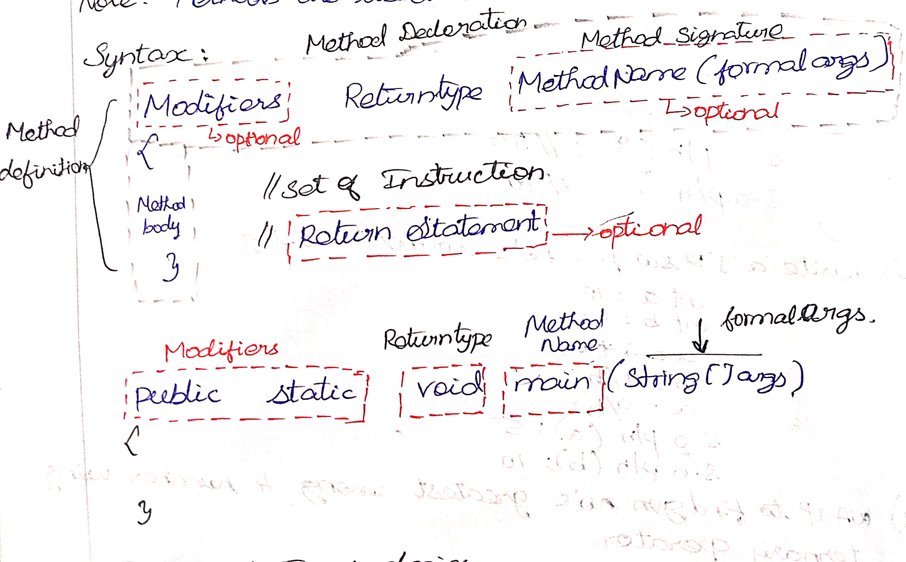
S.o.p( ); } }

METHODS :
Methods are nothing but set of instr.. which are used to perform some specific task

- Without returntype and without formal arg ,With return type and without formal
- Without return and with formal, with return type and with formal

TYPES OF MODIFIERS
MODIFIERS
Access Modifiers Non access modifiers

Access modifiers- public , protected, default (pkg-level) , private.
Non Access modifier – static , non static, abstraction, final etc..
TYPES OF METHODS
BASED ON ARGUMENT, BASED ON MODIFIERS.
Zero arguments method Static ,nonstatic,abstract, final method
Parameterized method
Program: class demo { // zero Arugument method class { // parameterized
// caller Psvm(){ s.o.pl(“ms”); psv add(int a , int b ){
add(); s.o.p(a+b);
add(); }
s.o.pl(“me”); } psvm(){
//called methd public static void add( ){ s.o.p(“ms”);
int a= 10; add(10,20);
int b = 30; add(100,200);
s.o.pl(a+b);} add(60,50); s.o.pl(“me”); }

//with returntype & without formal args //with returntype & with formal args
P.s. int m1(){ called p s int sub(int a , int b){
Int a = 15; int res = a-b;
Int b= 5; return res;
Int res = a*b; psvm(){
Return res; } s.o.pl(sub(10,5));
Psvm(){ //caller int res = sub (10,20);
Int res = m1(); s.o.p(res); }
s.o.p(res);// 75
s.o.p(m1());//75
int res1 = m1(); // 75 s.o.p(res1);
TYPES OF FUNCTION CALL - FUNCTION CALL NOTHING BUT METHODS
- CHAIN FUN CALL
- SEQUENCE FUN CALL
- RECURSIVE FUN CALL
CHAIN FUNCTION CALL
- One fun (method) calling another fun and that fun call another fun is chain fun call.
Main() m1(); m2(); m3();
------------------
------M3()

M2();;

M1()

SEQUENCE FUNCTION CALL
calling the fun or executing the fun in sequential order (one after other)
-----
-----
------
main() m1()
M1() m2()m3()

m2()

m3()
program: class sample{ psvm(){
- p s void print(int a ){ print( 5);
for(int i = 1; i<=a; i++){ check(7);
s.o.p(i); } } } }
p s void check(int a ){
int count = 0;
for(int i = 1; i<=a; i++){
if(a%i==0){ count ++; } }
if(count == 2){ s.o.p(“pn”); }
else { s.o.p(“not pn”); } }
RECURSIVE FUNCTION CALL - One fun call another fun and that fun call itself
Main() check ()
------check()
Check();

PROGRAM: PSVM(){
Print(1);}
Psv print(int num){
If(num<=10){
Sop(num++);
Print(num); }}
SCANNER CLASS
Scanner is pre-defined class which is present in java.util package. It is used to read input from the user.
STEP 1 : IMPORT syntax: import java.util.Scanner;
STEP 2: Scanner s = new Scanner (System.in);
SCANNER CLASS METHOD
Byte next Byte();
Short next Short();
Int next Int();
long next Long();
float next Float();
double next Double();
char next (). char at (int index);
boolean next Boolean();
string next (); good
nextLine(); good morning hellio sir
Program:
import java.util.Scanner;

public class pattern {
public static void main(String[] args) {
Scanner sc = new Scanner (System.in);

System.out.println("plz enter choice ");
int choice = sc.nextInt();

switch(choice) {
case(1) :
{
System.out.println("plz enter 1st data ");
int num1 =sc.nextInt();
System.out.println("plz enter 2nd data ");
int num2 =sc.nextInt();
add(num1, num2);
}
break;
case(2) :
{
System.out.println("plz enter 1st data ");
int num1 =sc.nextInt();
System.out.println("plz enter 2nd data ");
int num2 =sc.nextInt();
sub(num1, num2);
}
break;
case(3) :
{
System.out.println("plz enter 1st data ");
int num1 =sc.nextInt();
System.out.println("plz enter 2nd data ");
int num2 =sc.nextInt();
multi(num1, num2);
}
break;
case(4) :
{
System.out.println("plz enter 1st data ");
int num1 =sc.nextInt();
System.out.println("plz enter 2nd data ");
int num2 =sc.nextInt();
div(num1, num2);
}
break;
case (5):
{
System.out.println("thanking you");
System.exit(0);
}
break;
default:

}
}
public static void add(int a , int b) {
System.out.println(a+b);
}
public static void sub(int a , int b) {
System.out.println(a-b);
}
public static void multi(int a , int b) {
System.out.println(a*b);
}
public static void div(int a , int b) {
System.out.println(a/b);
}
} printprime , givenprime , evennumber , oddnumber

ASSIGNMENT:

ARRAY

Array is a continuous block of memory which has logically broken into number of pieces.

CHARACTERISITICS:
  - Array is homogenous in nature, it is fixed in size
  - Each and every elmt in array identified with unique index position that start from 0.

Array declaration: datatype [ ] identifier; or datatype identifier[ ]; ex: int a[ ]; ,INT[ ] A ;
Array creation : identifiers = new datatypes[size]
Ex: a = new int[5];
Array intilization: identifier [index] = value; Ex: a[0] = 15; a[1] =16

public class Array {

public static void main(String[] args)

{
// TODO Auto-generated method stub
Scanner s = new Scanner (System.in);
System.out.println("enter array size");
int size = s.nextInt();
int[] arr= new int [size];
System.out.println("enter array element");

for(int i= 0;i<size;i++) {
arr[i] = s.nextInt();

}
print(arr);

}

private static void print(int[] a) {
for(int i= 0;i<=a.length;i++) {

System.out.println(a[i]);

}

}

ASSIGNMENT:
- CREATE A METHOD WHICH WILL PRINT EVEN NO FROM A GVN ARRAY
AND READ INPUT FROM THE USER TO CREEATE AND STORE ELEMENT IN THE ARRAY.

- FIND SUM OF EVEN NOS FROMM A GVN ARRAY.
- WAJP TO FIND THE SPECIFIC ELEMENT FROM A GVN ARRAY
- FIND MAXIMUM ELEMENT FROM A GVN ARRAY.
- FIND SUM OF ODD NOS FROMM A GVN ARRAY.

PART -2
OOP CONCEPTS- OBJECT ORIENTED PROGRAMMING .
OBJECT
CLASS
ABSTRACTION
ENCAPSULATION
INHERITANCE
POLYMORPHISM
In technical term we call oops as PARADIGM.
OOP : It is a design pattern or paradigm , helps to develop real world software like ola, uber, flipkart ..etc. by considering real world entities.
OBJECT: object means real world entity which is existing physically. Ex: pen
What is object from java point of view?
Object is one block of memory which has multiple variable and methods.
Why do we need object?
Object is used To represent real world entity in software world.

REAL WORLD ENTITY
PROPERTIES (VARIABLE)

BEHAVIOURS(METHODS)
BOOK

VARIABLES - ID, NAME, AUTHOR, PRICE….
METHODS - READ(); , WRITE();, STUDY();…..
SOFTWARE WORLD
ADDRESS

ID – 101
NAME- JAVA
PRICE- 20,000
AUTHOR - GAMES

READ();
WRITE();
STUDY();
READ();
WRITE();
STUDY();

OBJECT
STEP TO CREATE OBJECT:
STEP1 : BLUEPRINT MANDATORY, BLUEPRINT IS NOTHING BUT CLASS.
CLASS: class is a component in java.
It is required mainly for 2 reasons.
- To execute java program
- Class will act like blueprint of object.
STEP 2: SYNTAX: NEW CONSTRUCTOR( );
NEW : keyword , create object return object address, each and every object u
Unique add.
CONSTRUCTOR - Load member of the class, same name as a class name
Program: class Book{
Psvm(){ s.o.p(new Book());
s.o.p(new Book()); } }
MEMBER OF THE CLASS:
It is classified into two types, 1)static member, 2)Non Static member
STATIC MEMBER , classified into 2 types:
- Static variable 2) static methods
present in same class- accessed just by using memberame.
Present inndiff class - accessed by classname.membername
Program://Accessing static member within same class
Class student{
//static variable
Static String clgName; o/p: null, 0 , 0.0
Static int a;
Static double b;
//static method
Public static void display( ){
System.out.println(clgname);
s.o.p(a);
s.o.p(b); }
psvm( ){ display();
SOUT( a); } }
//Accessing static member within different class
Class main {
Public static void main(String [] args){
Student.display( );
s.o.p(student.clagname); } }
NON-STATIC MEMBER , classified into 2 types:
- Non Static variable 2) Non static methods
present in same class- accessed within Static method only by creating a object class, accessed within Non static method directly by using membername.
PROGRAM:
Class employee{
Int id ;
String name ;
Public void print()[
// directly sout(id);}
Psvm(){
//by creating object accessing print () o/p:
new employee( ) .print( );
sout(new employee().name); } }
Present in diff class - accessed by
Class main {
Public static void main(String [] args){
new employee().print( );
s.o.p(new employee().name); } }

Access modifier  Location | Static | Non static
Same class | Just by using member name | Static method: only by creating object of class  Non static: acces member name.
Diff class | Using  classname. Member name | Only creating object of class.

public class Account {
int id = 101;
String name = "Dinesh";
Long accountno = 676872878009l;
String email = "dinesh123@gmail.com";
double bal = 500;
static String bname = "Axis bank";

public void withdraw(double amt) {
bal -= amt;
System.out.println("withdraw succesfully");
}

public void deposite(double amt) {
bal += amt;
System.out.println("deposite succesfully");
}

public void checkbal() {
System.out.println(bal);
}

public void print() {
System.out.println(id);
System.out.println(name);
System.out.println(accountno);
System.out.println(email);
System.out.println(bal);}

public static void display() {
System.out.println(bname);}

public static void main(String[] args) {
new Account().withdraw(400);
new Account().print();

display();}

GLOBAL VARIABLES
Any variable which are declared in a class block call global variable.
- Class demo {// global var
Static int a = 50;
Psvm( ){
// local vartiable
Int a = 30;
Sout(a);//30
Sout (demo.a);//50 } }

- Class nonstatic{
Int a = 50;
Public void m1(){
Int a = 80;
Sout(a); //80
SOUT (this.a);//50
SOUT(this); .// address
Psvm(){ New nonstatic().m1(); }
Class A {
Static int a = 5;
Int b= 10;
P s v m1(){
Int a = 10;
Sout(a); }
Publc void m2(){
Int b= 80;
s.pl(b);
sout(this.b);
sout(this.a);
this.m1(); }
psvm(){
new A().m2();

Non Primitive Variable/ reference variable
It is type of variable which is used to store the address of an object.
Multiple reference variable point to same object .
Syntax:
Declation : classname reference var ex: student e1;
Inti.. : ref var = new2 constructor(); ex: e1 = new student ();
Dac and int… : student e1 = new student();
class demo{
int id ;
String name;
public void print() {
System.out.println(id);
System.out.println(name);}
public static void main(String[] args) {
Account e1 = new Account();
System.out.println(e1);// adsdress
e1.print();
e1.id = 101;
e1.name = "allen";
e1.print();
Account e2 = new Account();
System.out.println(e2);// adsdress
e2.print();
e2.id = 101;
e2.name = "kavi";
e2.print();
// multiple reference pointing to same object
Account e3 ;
e3 = e1;
System.out.println(e3);// adsdress
System.out.println(e3.id);//101
e1.id = 105;
System.out.println(e3.id);//105 }}

CONSTRUCTOR
- Constructor are special type of method which have same name as classname.
- Every class must have constructor , if programmer donot write any constructor then complier will write default constructor implicity.
- Classified 2 types: zero arg constr , parameteriozed arg constr.
- Constructor cannot be declared as static or final.
Example:// zero argument constructor
Class Demo{
Public demo(){
Sout(“hello”); }
Psvm( ){ new Demo(); }
Example:// parameterozied argument constructor
public class jio {

int id ;
String name;
long mobno;
String email;

public jio(int id, String name, long mobno, String email) {

this.id = id;
this.name = name;
this.mobno = mobno;
this.email = email;}
public void print() {
System.out.println(id);
System.out.println(name);
System.out.println(mobno);
System.out.println(email);
}
public static void main(String[] args) {
jio j1 = new jio(101, "smith", 786986897l,"smith2123gmail.com");
j1.print();

}

CONSTRUCTOR OVERLOADING
Devloping multiple constructor within same class with the same name which differin 1. No of Arugments ,
2. Datatypes of arg ,
3. Order of arg,.
Class jio {
public jio() {
System.out.println("zero");
}

public jio(int a) {
System.out.println(a);

}
public jio(double a) {
System.out.println(a);
}
public jio(int a , int b) {
System.out.println(a+b);
}
public jio(double a , int b) {
System.out.println(a+b);
}
public jio(int a , double b) {
System.out.println(a+b);
}
public static void main(String[] args) {
jio();
jio(10.5);
jio(10, 20) } }

PROGRAM:
public class Googleform {
String name;
long mobno;
String email;
static String clgname = "srm clg";

public void print() {
System.out.println(name);
System.out.println(mobno);
if ( email!= null) {
System.out.println(email);
}
System.out.println(clgname);
}
public Googleform(String name, long mobno, String email) {
this.name = name;
this.mobno = mobno;
this.email = email;
}
public Googleform(String name, long mobno) {
this.name = name;
this.mobno = mobno;
}
public static void main(String[] args) {
Googleform g1 = new Googleform("allen", 657698789l);
Googleform g2 = new Googleform("ford", 6576985589l, "ford@gmail.com");
g1.print();
System.out.println("---------------");
g2.print();
System.out.println(g1.clgname);
}
METHOD OVERLOADING
Devloping multiple methods within same class with the same name which differin 1. No of Arugments ,
2. Datatypes of arg ,
3. Order of arg,.
Note: it is easy to remember one method which may perform similar operation with doifferent argment.

When to achieve method overloading :
When method have same functionality (same operation) then we will achieve method overloading

JAVA PACKAGE
A java package is group of class and interface which are related to one single modules in given project.

- using fully qualified class name
- using import stmt.

ACCESS MODIFIER / SPECIFIERS

  - Access modifiers are used to provide security for the classes and it member by controlling the visibility.
  - Four types of access modifiers.
- Public
- Protected
- Default
- Private
PUBLIC
  - It can be access by the classes present in same or different package.
  - Higy visibility and low security.

PRIVATE
- it can accessed only by the class within same class
DEFAULT
- it can be strichly accessed only by the classes present in a same package.
PROTECTED
- it can be accessed by the classes present in same package.
- it can be accessed by another class present in diff package
passing through inheritance and creating the object od subclass only.

INHERITANCE
Inheritance in java is a machanism where one class(child or subclass) acquires the properties and behaviour(fields and methods) of another class (parent or superclass).,
PROGRAM:
class Instagram {
//parent / super class
String name = "kavi07";
public void mgs() {
System.out.println("mgs send");
}
}
class Instagramv1 extends Instagram{
//child / sub class
public void status() {
System.out.println("upload status");
}
}
public class MAIN {
public static void main(String[] args) {
Instagram i = new Instagram();
System.out.println(i.name);
i.status();// CSE
i.mgs();
Instagramv1 i1 = new Instagramv1();
i1.status();
i1.mgs(); }}

FINAL KEYWORD:
Final means fixed or constant, if any variable or methods declared with a keyword called final then data cannot be modified. And intilization is mandatory.
class book {
final int a = 10;
public final void m1() {
System.out.println(" hello hi ");
}}
public class teacher extends book {
int b = 20;
public static void main(String[] args) {
teacher t1 = new teacher();
System.out.println(t1.a);
System.out.println(t1.b);
t1.m1();
t1.b =25;
t1.a =70;// becz final variable
System.out.println(t1.b);
}}
DIFFERENT TYPES OF INHERITANCE.
Five type of inheritance,
- Single inheritance
- Multi level inheritance
- Multiple inheritance
- Hierarchial inheritance
- Hybrid inheritance.
Single Inheritance:
One subclass inheriting from one single superclass.
public class student {
final int v = 10;
String str ;
public void test() {
System.out.println("display2");
}
public void count() {
System.out.println("display1");
}
public static void main(String[] args) {
Demo d = new Demo();
d.display();
d.test();
d.count();}}

class Demo extends student{
double b = 0.5;
public void display() {
System.out.println("display"); }}

MULTI LEVEL INHERITENCE
subclass inheriting the properties of superclass and that superclass inheriting another superclass properties.
PROGRAM:
class whatsapp{
void mgs() {
System.out.println("mgs send");
}}
class whatsapp1 extends whatsapp{
void voice() {
System.out.println("audio");
}
}
class whatsapp2 extends whatsapp1{//sub class
void status() {
System.out.println("status uploaded");
}
}
public class DEMO1 {

public static void main(String[] args) {
whatsapp2 w = new whatsapp2();
w.mgs();
w.voice();
w.status();}}

HIERARCHICAL INHERITANCE
One superclass inherited /extended by two or more subclasses is called as hierrachial inheritance.
HYBRID INHERITANCE
It is the combination of multiple inheritance and any one type of inheritance.
MULTIPLE INHERITANCE
Subclass inheriting the properties from 2 or more superclass .
Java don’t support multiple inheritance .
Multiple inheritance can be achieved with the concept called as interface.
STATIC BLOCK AND NON STATIC BLOCK
Static block are alos known as static intilizer
Static intilizer will get executed before the execution of main method and during class loading process.

EX: CLASS DEMO {
Static{
SYSOUT( “STATIC INTILIZER”); }
NON STATIC BLOCK
Non Static block are alos known as non static intilizer
Non static intalizer will get executed during object creation and before the execution of constructor.
PROGRAM:
public class nonstatic {
//non static intilizer
{
System.out.println("non-static intilizer");
}
public nonstatic() {
System.out.println(" constructor");
}
public static void main(String[] args) {
System.out.println("ms");
new nonstatic();
System.out.println("me");}
{
System.out.println("good morning");}
}

Note: Main method has been implemented from jdk 7 .
JDK :
Jdk stands for Java development kids , jdk is platform dependent.
Jdk provided development tools which develop java application.
It includes java runtime environment(JRE) , an interpretor
JDK – JAVA DEVELOPMENT KIT
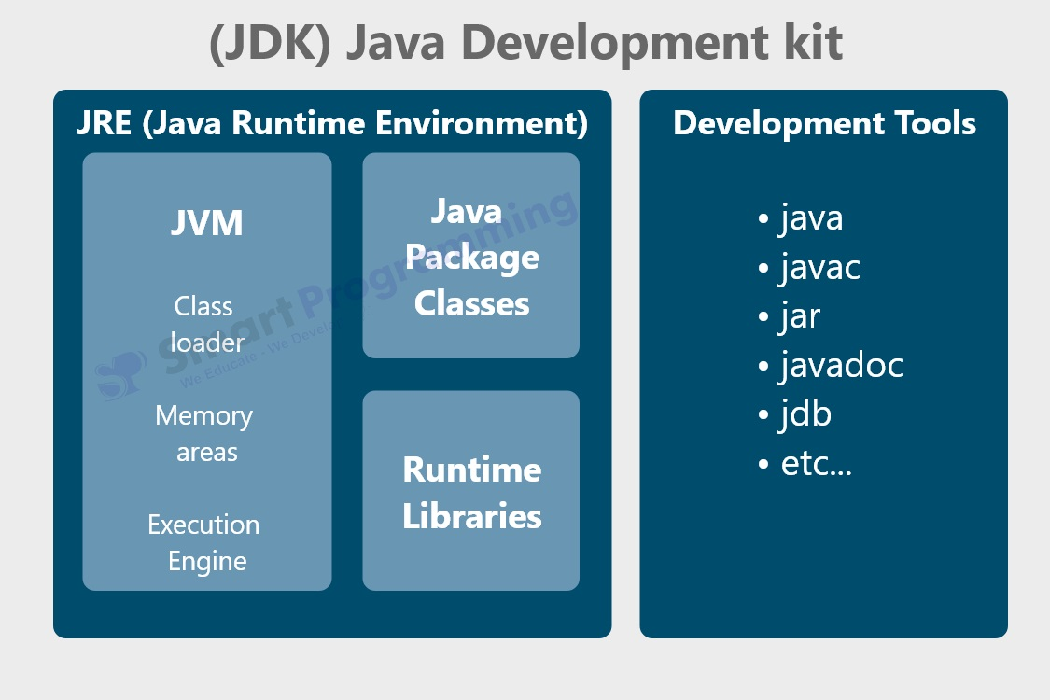

JRE (JAVA RUNTIME ENVIRONMENT)
JRE will provides runtime environment to execute java program , it contains JVM.
JVM – JAVA VIRTUAL MACHINE ( JVM INTERPRETOR)
Jvm will handle comple runtime execution process and memory allocation. Jvm contain 3 major components.
Class loader , runtime areas, execution engine.
Method area
Static area
Stack complete execution
Heap area
In exection engine we have ,
Interpertor –convert bytecode into binary code .
JIT- just in time , that improve the performance of java applt..
GARBAGE COLLECTOR

Program:
Class Demo{
Static int a = 10; o/p
Static { sysout(“static”); } static
Psvm(){ ms
sysout(“ms”); 10
sysout(a); me
sysout(“me”); }
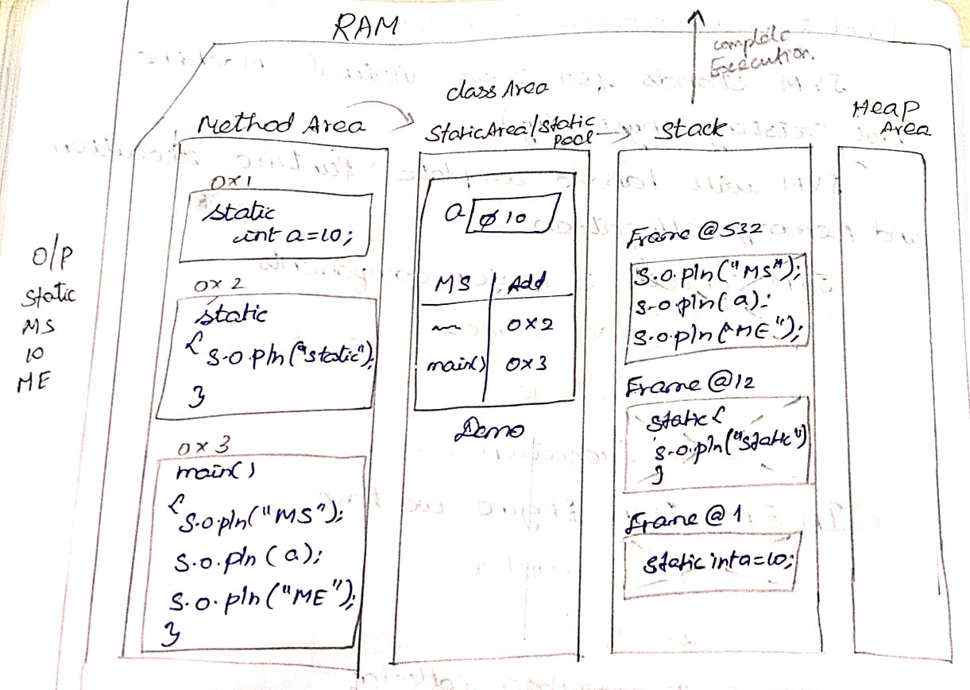

PROGRAM:
Class parent {
Static{ sys(“parent”); }
}
Public class child extends parents{
Ststic { sys(“child”); }
Public static void m1(){
SYSOUT(“m1 method”); }
Psvm( ) {
Suysout(“ms”);
M1();
Sysout(“me”); }

CONSTRUCTOR CHAINING
One constructor calling another constructort and so on …
Constructort chaining can be achieving in 2 things
- this ( ) - This stmt.
- super () super stmt.
This ( ) : This statement:
This stmt is used to achieve local constructor, written only in constructor body and within 1st line only.
To use this stmt constructor overloading is mandatory. \
PROGRAM:
public class STATIC {

public static void main(String[] args) {

new STATIC(8.9);}
public STATIC() {
this(10);
System.out.println(" zero");
}
public STATIC(int a) {
System.out.println("integer");
}
public STATIC(double b) {
this ();
System.out.println("double");
}}

SUPER ( ) : SUPER STMT:
  - Super ( ) ; create the object of superclass whenever object of subclass is created to inherit the peoperties.
  - Always superclass object should be created 1st then inherited to subclass object and always written 1stline of constructor body.
  - Multiple super( ) is not allowed .
Program:

class demo extends Object{
int a = 50;

public demo() {
super();
System.out.println("demo constructor");}

class demo1 extends demo{
int C = 80;
public demo1() {
super();
System.out.println(" main constuctor");
}}
public class STATIC {
public static void main(String[] args) {
demo1 d = new demo1();
System.out.println(d.a);
}

DIAMOND PROBLEM IN JAVA
OBJECT

SAMPLE

DEMO

M1( ) {
}

M1( ) {
}

MAIN
Psvm {
M1( ); }

Why java do not support multiple inheritance ? or Explain diamond problem in java?
- It create an ambiguity / confusion for the complier to choose the path from where properties of object class should be copied to subclass.
- To call multiple constructors of multiple super classes we should write multiple super( ) ; which is not supported in java.
- If both super classes have methods with same aguments then it creates an ambiguity for the complier to choose which method should be called for execution when it called subclassobject.

METHOD OVERRIDING
- subclass inherting method of superclass and changing the method definition according subclass speciofication without changing method declaration .
- inhetitance is mandatory for method overriding.
SUPER KEYWORD
Super keyword is a special built in reference variable which is created by jvm.
Super keyword is used to access immediate parent class properties.
Program:
class whatsapp{
void mgs() {
System.out.println("single tick");
}}
class whatsapp1 extends whatsapp{
@Override
void mgs() {
System.out.println("double tick");
}
}
class whatsapp2 extends whatsapp1{//sub class

@Override
void mgs(){
System.out.println("blue tick");
}}
public class DEMO1 {

public static void main(String[] args) {
whatsapp2 w = new whatsapp2();
w.mgs();
}}

TYPE - CASTING
DERIVED CASTING- Converting one obj reference type of another object ref type called derived casting . there are 2 types.
- Upcasting
- Downcasting
Upcasting :
- Converting subclass object reference to superclass object ref called upcasting.
- Any upcasted ref variable pointing to subclass object , we can access only properties of superclass in the subclass object and it is impossible to access subclass properties implicity by the comipiler .
Note: To achieve upcasting inheritance is mandatory .
PROGRAM:
class sample {
int b = 78;
}
class Demo extends sample { //superclass
int a = 50;
void m1() {
System.out.println("i am superclass");
}}
class Main extends Demo{ // subclass
int k = 40;
void m2() {
System.out.println("i am subclass "); }}
public class Upcasted {
public static void main(String[] args) {
// upcasting
Demo d1 = new Main();
d1.m1();
System.out.println(d1.a);
System.out.println(d1.b);
// d1.m2();//CTE}}

DOWNCASTING :
- Converting upcasted object reference back to subclass object reference is called downcasting.
- Using an downcasted reference we can access properties of superclass and subclass
- To achieve downcasting upcasting is mandatory. Explicity by the programmers
Syntax : Classname ref = [class name] upcasting reference;
PROGRAM:
class Test{
double maths = 99.1;

void student() {
System.out.println("pass");}
}
class annual extends Test{
double f = 70.4;
void exam() {
System.out.println(" fail");
}}
public class Downcasting {

public static void main(String[] args) {
Test t1 = new annual();
t1.student();
System.out.println(t1.maths);
// System.out.println(t1.f);//cte
//downcasting
annual a1 = (annual) t1;
System.out.println(a1.f);
a1.student();}
}

What is class cast exception ?
Whenever we try downcast an upcasted reference to different class ref
Which do not contains the properties of given object, then jvm will throw classcast exception.

Polymorphism :
One entry showing different behaviours at different places is called polymiorphism.
Polymorphism is of two types :
- Compile time polymorphism.
- Runtime polymorphism
Compile time polymorphism
- Binding the method declaration to method definition by the compiler at the compile time based on the arguments is called as compile time polymorphism
- Since the binding is done before the execution it is called as early binding.
- Once the binding is done it cannot be changed at the runtime and hence it is also called static binding.
- Method overloading and construction is the beast example for compile time polymorphism.

Golden Java Rule :
- using an upward reference if you call an overriden method than you always get the implementation of subclass.

Runtime Polymorphism :
- Binding the method declaration to method definition by the JVM at the run time based on the object creation is called as run time polymorphism.
- Since the binding is done during the execution it is called as late binding
- Once the binding is done it can be changed at the runtime and hence it is also called as dynamic binding.
- Method overriding is the best example Run time Polymorphism..
Abstraction :
- Abstract means incomplete
- A method which has only method declaration and no method definition is called as abstract method.
- Abstract method must be declared by using abstract keyword.
- If a class contains atleast one abstract method, it is impossible to create an object of an abstract class.
- We can create reference variables of abstract class type.
- A method which has both method declaration and method definition is called as concreate method.
- If a class contains only concrete method, then the class is called as concrete class.
- Concrete method is nothing but implemented method

